This document is a brief guide on installing the software for **Windows 10** users

People using RP issued laptop in which you don’t have admin rights, please go to HelpDesk to get all software installed. Remind Helpdesk that MySQL Server services has to auto start when you start up Windows as Windows Services Panel require admin password.

Pre-requisite Software

MySQL 5.7 Server requires the Microsoft Visual C++ 2015 Redistributable Package to run on Windows platforms. Users should make sure the package has been installed on the system before installing the server. The package is available [here](https://www.microsoft.com/en-us/download/details.aspx?id=48145) and in RP Software Center Application.

You need to have Microsoft NET Framework 4.5 already installed.

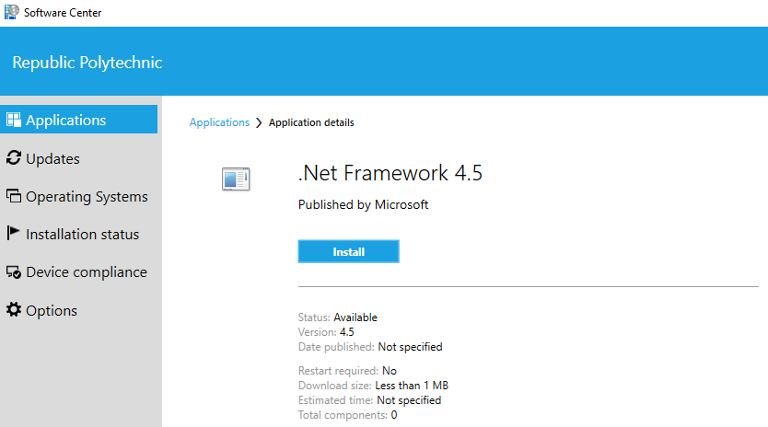

Existing Xampp and MySQL Server and Workbench

Xampp is not required. The ‘MySQL’ in Xampp is really Maria DB which is not what we are using. So, if you have Xampp, MySQL Server and Workbench, you need to uninstall it. You will also need to remove all directories and files associated with it. If not, you will face problems later.

Install MySQL Server 5.7

1. First download the Community Server 5.7.21 Installer file from Software Center or

[MySQL :: Download MySQL Installer (Archived Versions)](https://downloads.mysql.com/archives/installer/)

Select the first option, if you have an active internet connection. Otherwise, if you have to be offline, select the bottom download.

1. There is no need to login or sign up for Oracle Web account. Select ‘No thanks, just start my downlaod’.

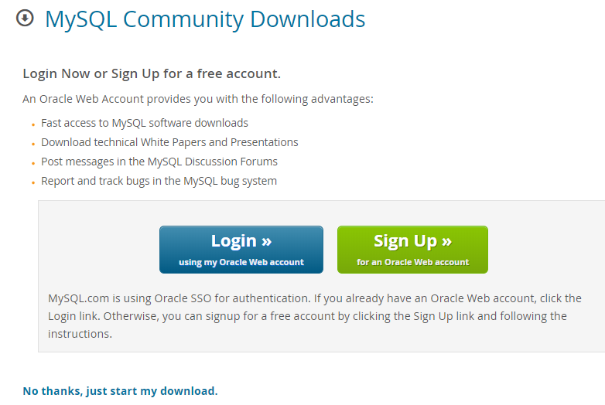

1. You may be asked whether you wish to allow the installer to update your PC and whether you wish to upgrade the installer. **For both, enter Yes.**

1. You will then be asked to provide your ID and password. This ID and password is the administrator password on your laptop. If you are using an RP issued laptop and do not have administration rights to your laptop you will have to approach HelpDesk to install the software for you.

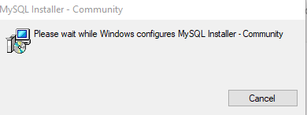

1. Next, you'll need to accept the software's license, which is the GNU Greater Public License, or GPL. Click **Continue**, then click **Agree** to move on.



1. During the initial setup, you are prompted to select the MySQL products to be installed on your laptop which will act as the host computer. Choose Custom.  
   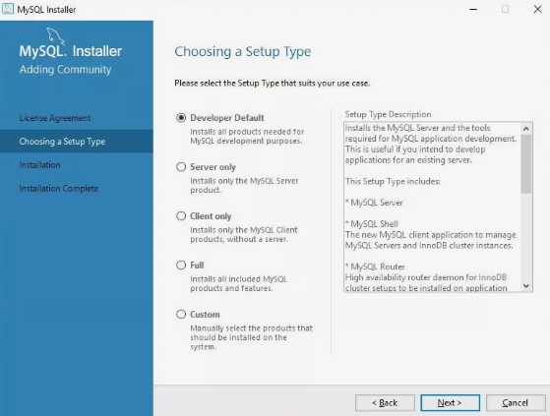

1. On the Select Products and Features screen, you'll need to move items from the left side of the screen to the right.
   1. First, open **MySQL Servers**.
   2. Then drill down to the server we need (MySQL Server 8.0.21) and select the **right-facing arrow**.
   3. Next, open **Applications**.
   4. Then drill down to **MySQL Workbench** and select the **right-facing arrow**.
   5. Both **MySQL Server** and **MySQL Workbench** are now selected for installation.

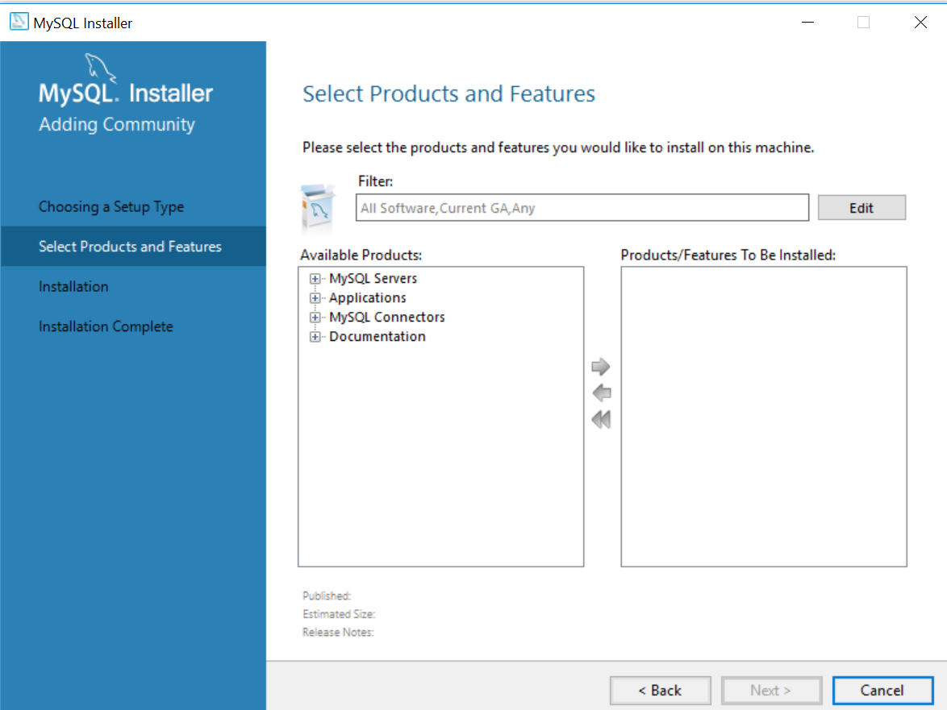

1. Now the installer will start downloading MySQL itself.

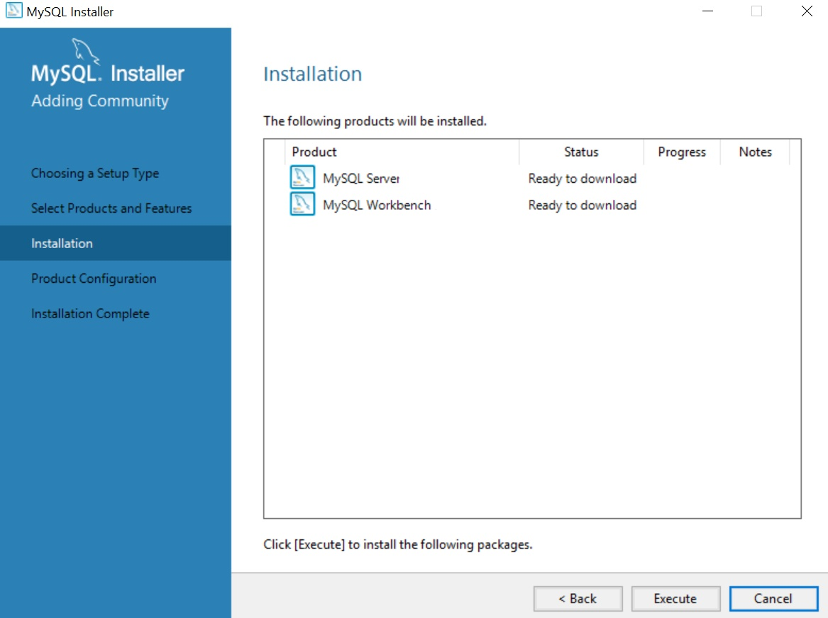

Once they're downloaded, they'll start installing. Your goal is to see your list with **Complete** statuses for everything. Once you do, select **Next**.

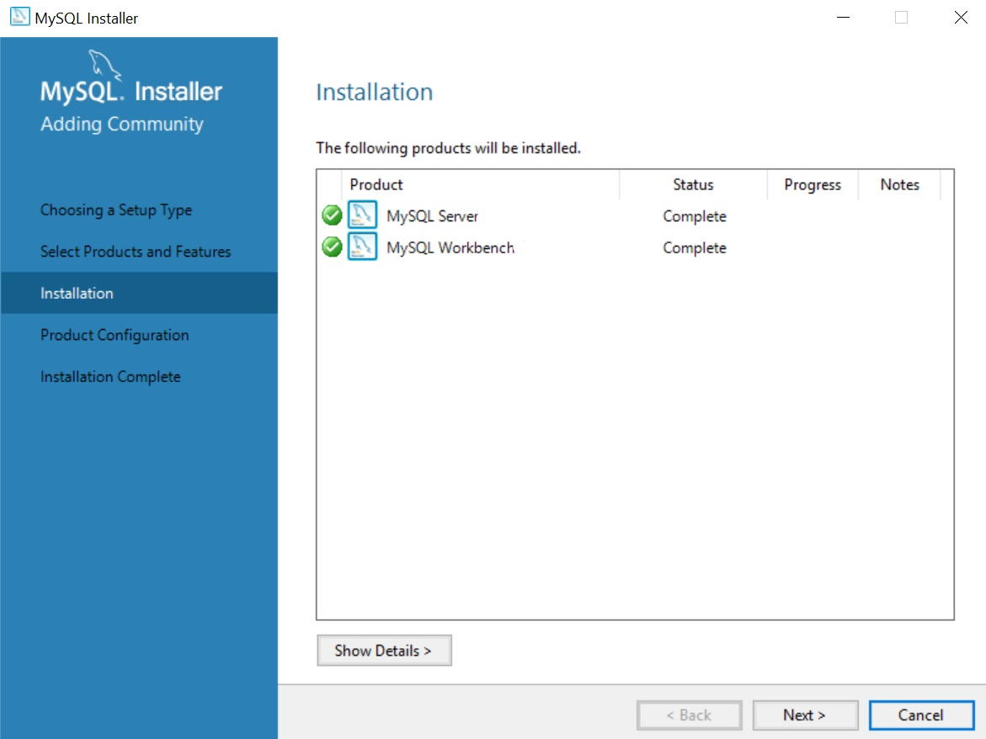

1. The wizard will then lead you through configuration. Configure the MySQL Server as follows:
   * + **High Availability**: Select **Standalone MySQL Server / Classic MySQL Replication**.
     + **Type and Networking**: Select the default Config Type **Development Computer**, which will set things up for you to work locally.
     + **Authentication Method**\*: Select **Use Strong Password Encryption for Authentication**.
     + **Accounts and Roles**: Enter a password for your MySQL root (i.e. admin) user.   
       **Enter ‘spring’ as the password. Since this is just a learning situation, a weak password is not critical.**
     + **Windows Service**: You can keep the defaults here, but you should select **Start the MySQL Server at System Startup**to disable it. As a general rule, try not to leave services you don't need running on your machine.

**Remember to select NEXT to advance to the next configuration settings.**

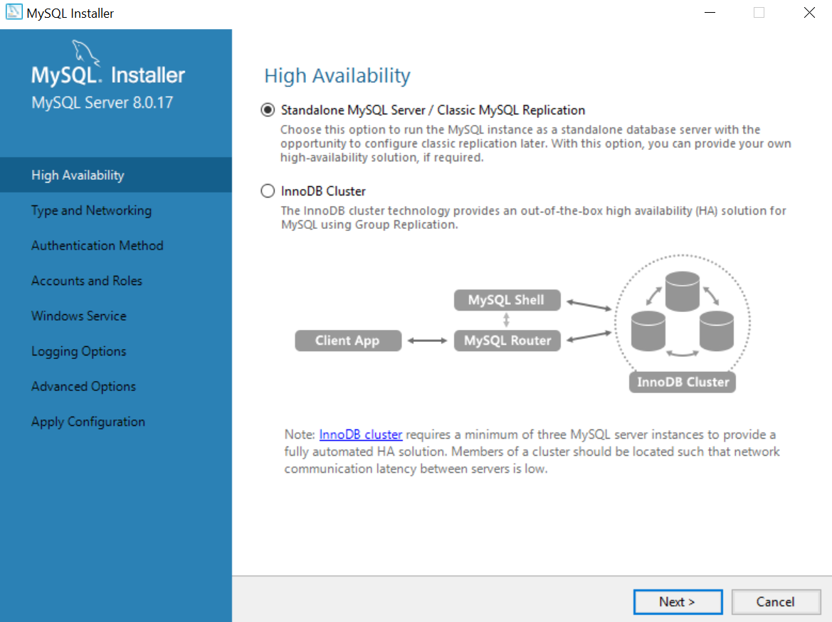

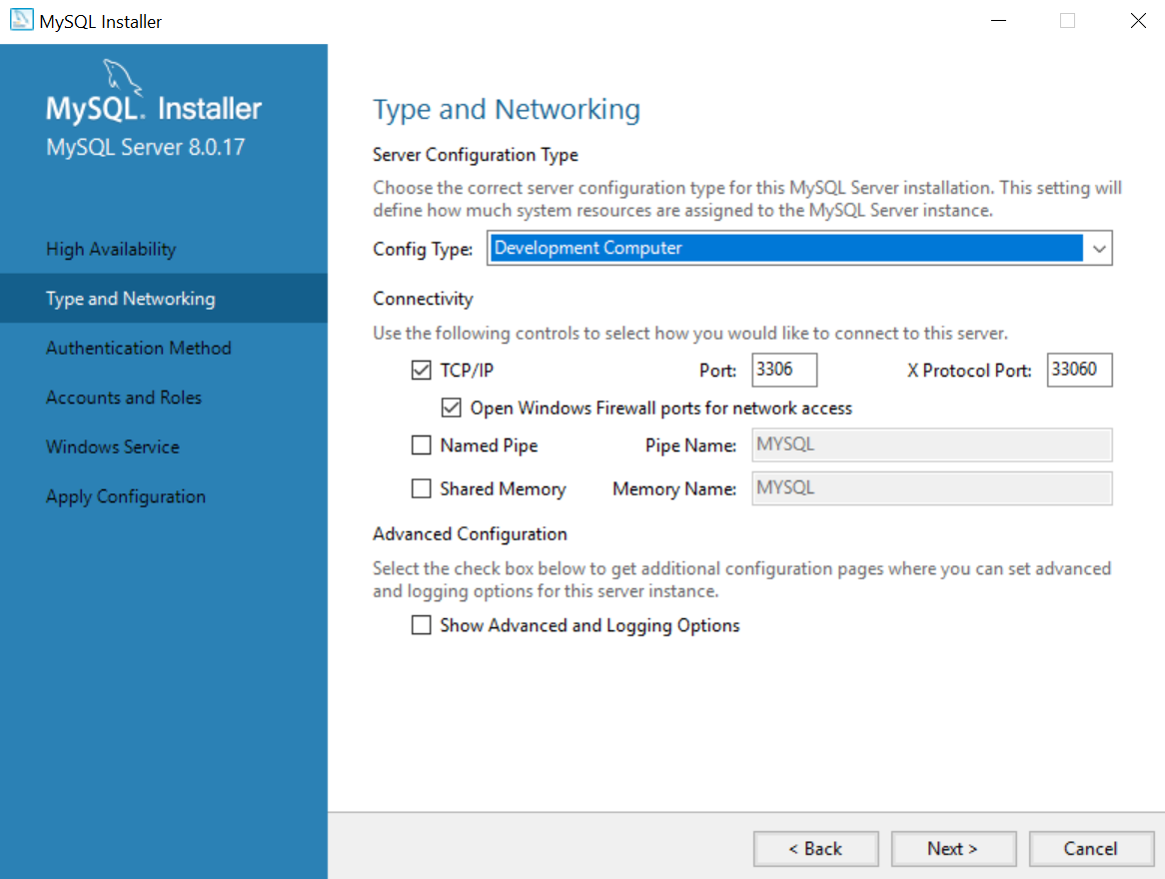

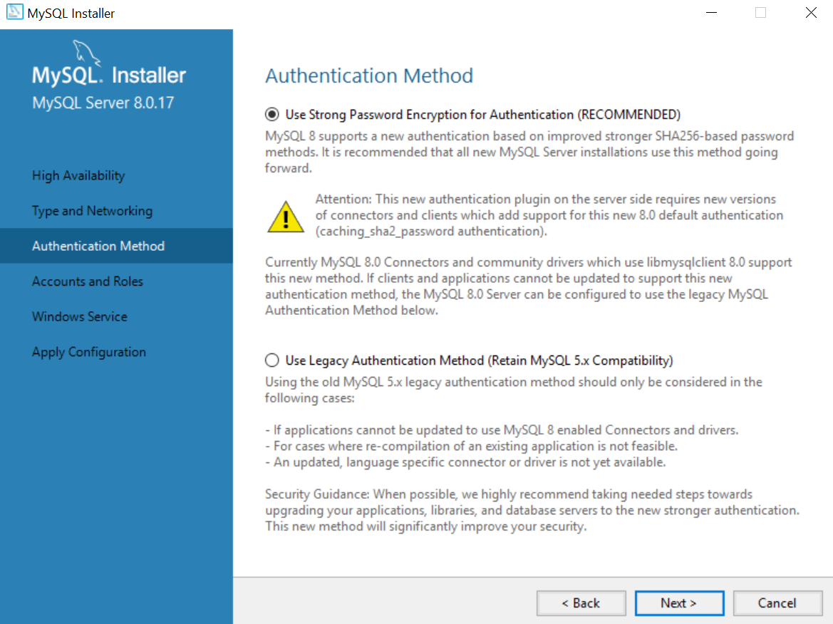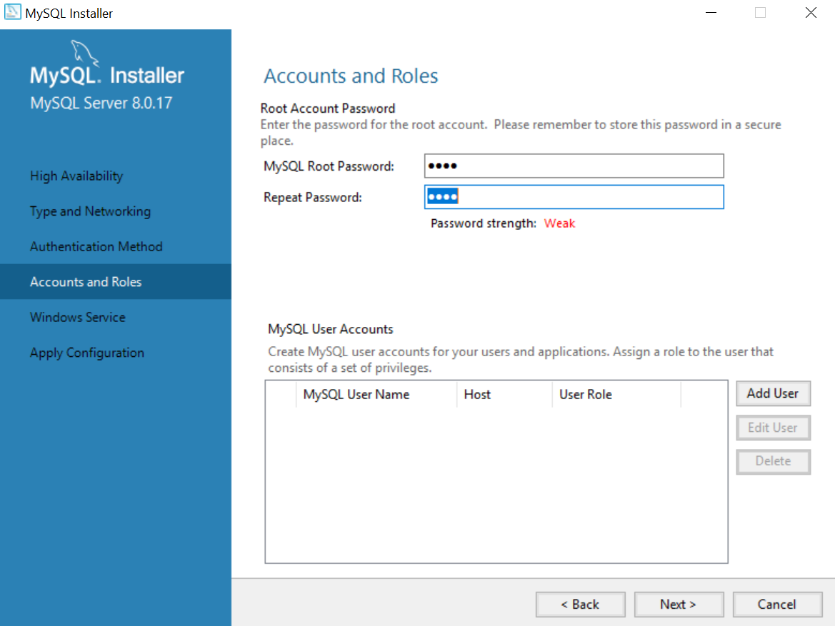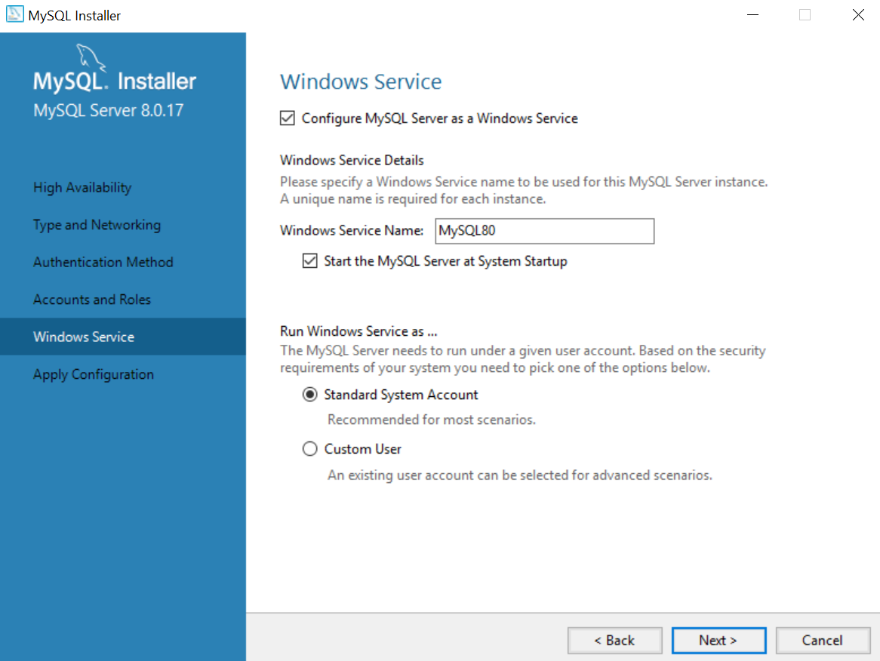

1. The default configuration for Windows Service is ‘Start the MySQL Server at System Startup’. You can leave it at default or you can chose to start the MySQL Server service manually.



If you chose to manually start the MySQL Server service manually, then untick the default.

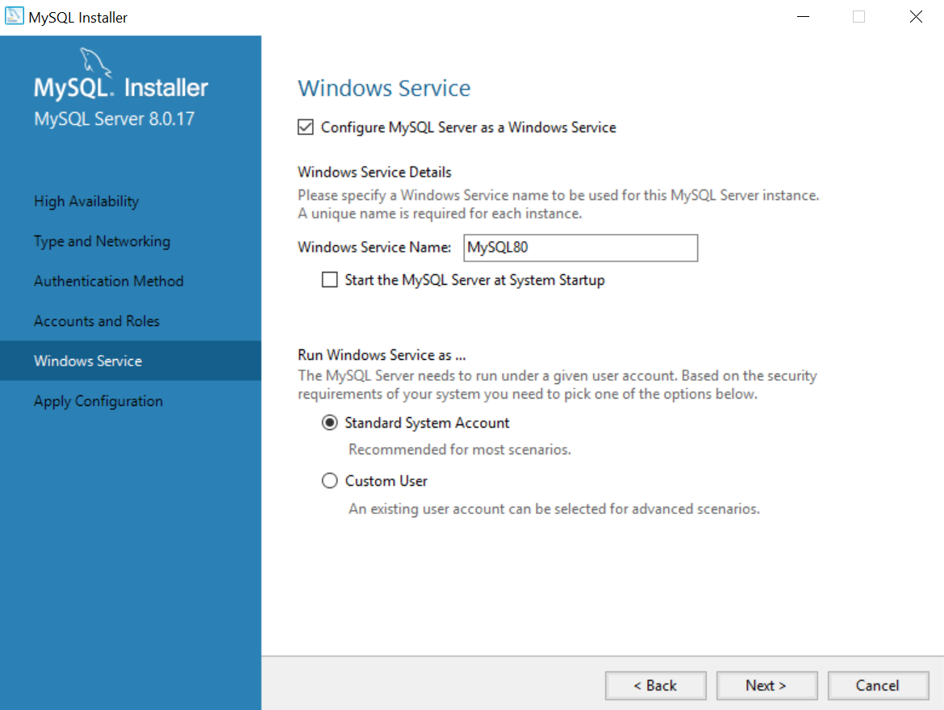

1. Select EXECUTE to apply the configuration.

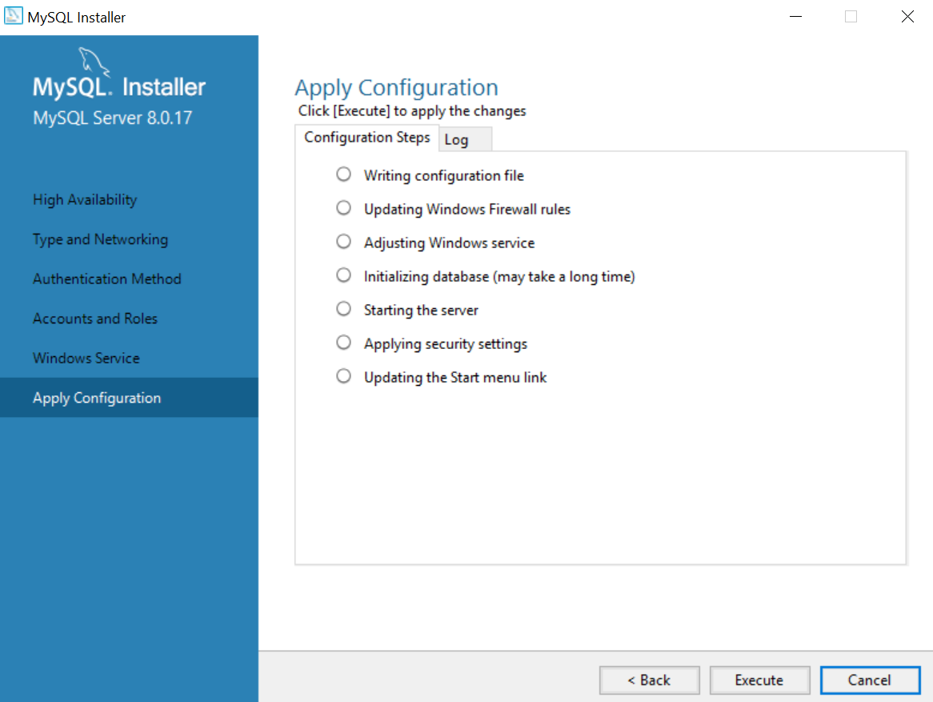

1. Select FINISH to complete your configuration and proceed to product configuration.

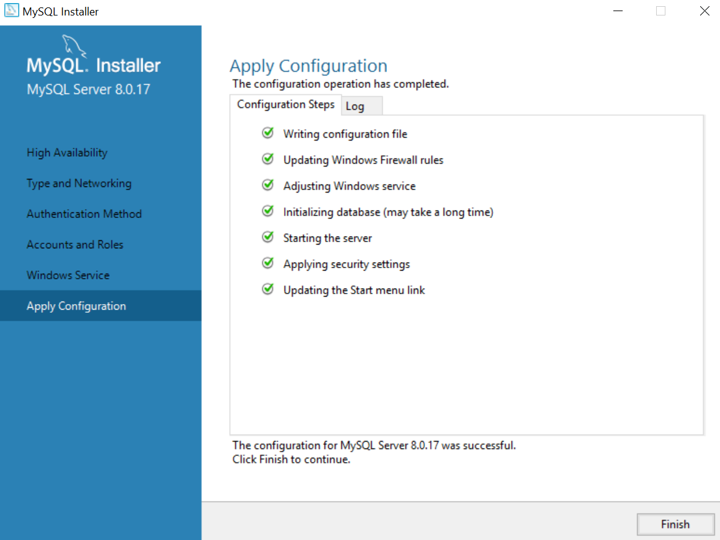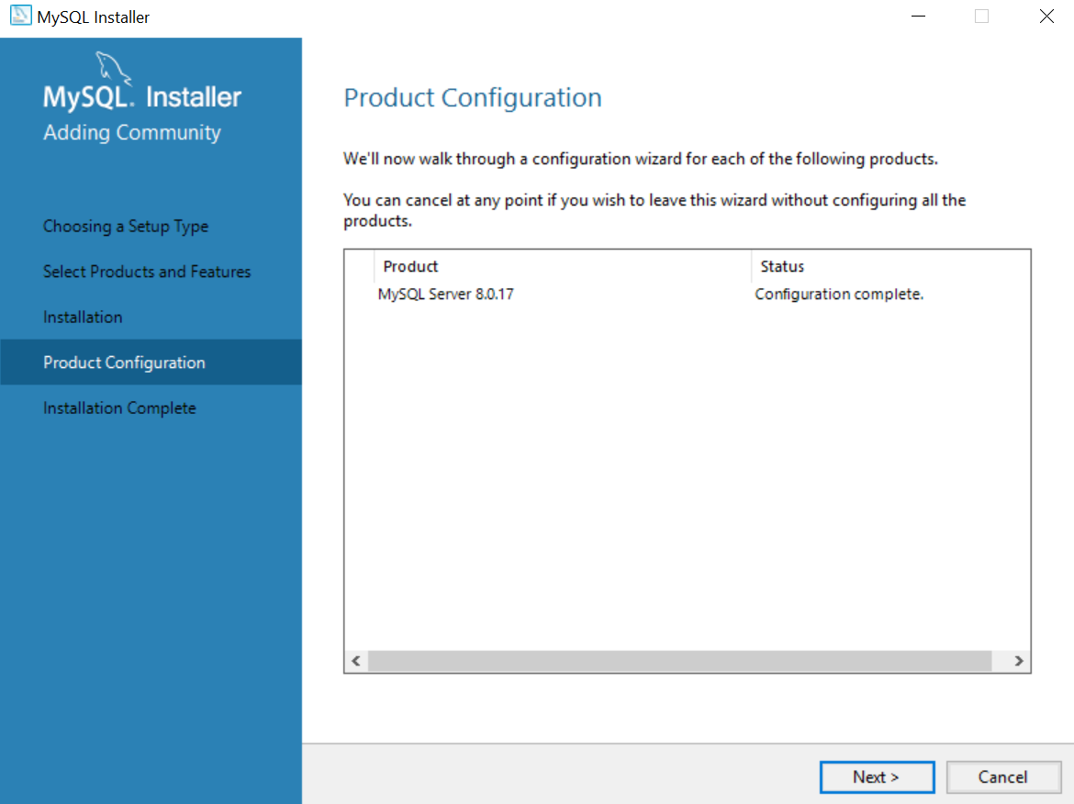

1. You will see the screen below which indicates that installation has been completed. Untick the option ‘Start MySQL Workbench after Setup’. You will learn how to start the app later. .

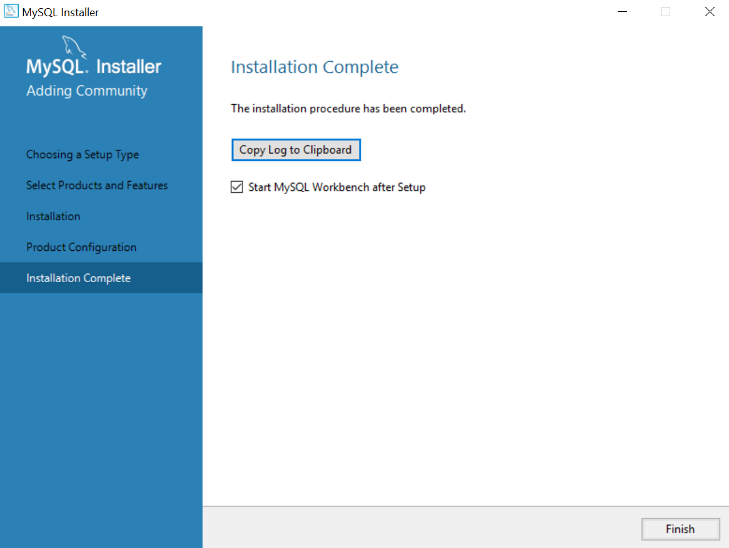

1. You will be wondering where is the MySQL Workbench App that you have just installed. Go to your  
   C:\Program Files\MySQL\MySQL Workbench 6.3 CE directory and you will find MySQL Workbench app there.
2. Right click the app icon  and select ‘Pin to Taskbar’

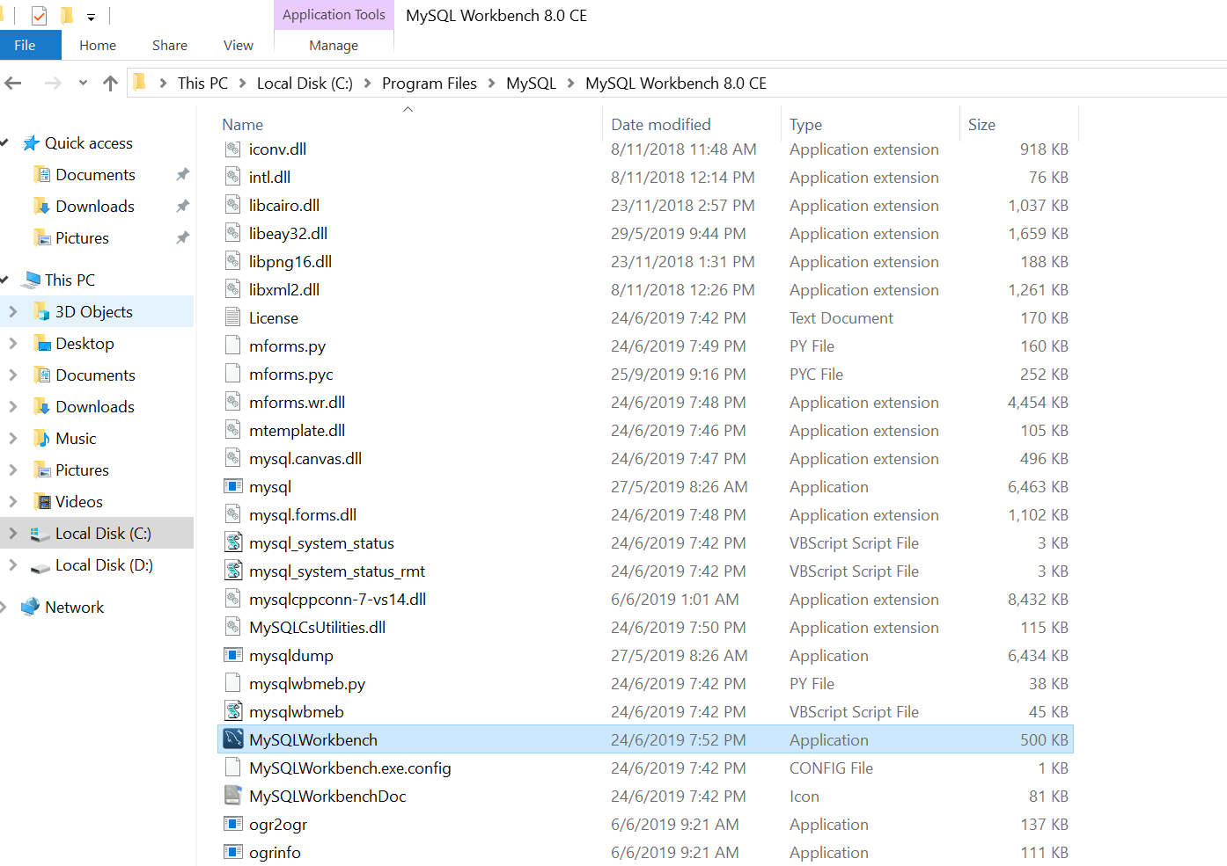

1. You will now be able to start MySQL Workbench from the task bar.



1. Before you use MySQL Workbench, it is necessary that the MySQL Server Service is started. If you have selected to start MySQL Server manually, you will need to refer to Starting MySQL Server for Windows 10 document; otherwise the MySQL Server Service is auto-started when you start Windows.